Today Lerato did something to my topology I will be taking troubleshooting steps to figure what she messed with .

Picture of topology of failed topology
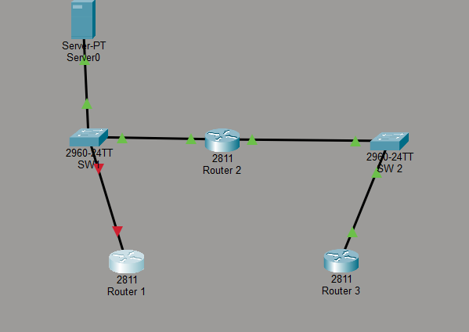

22. Showing faluire on the DNS server which is connected to client PC
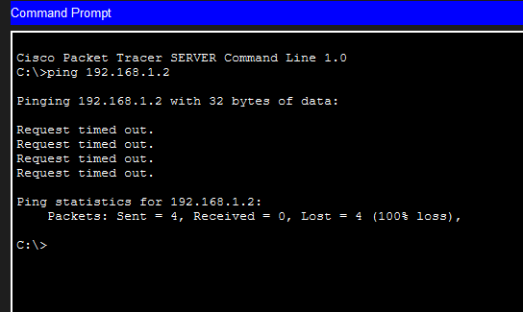
Work through OSI layer
Physical part
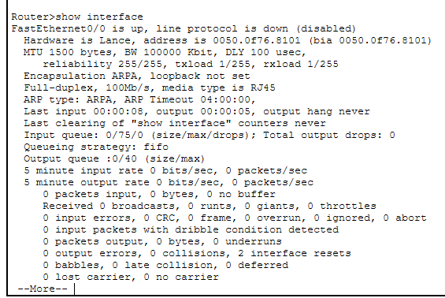
The fast ethernet 0/1 seems to be down so I will be looking deeper into a solution
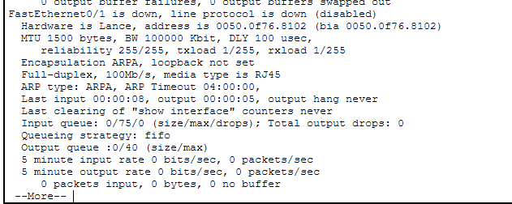
I found the solution , it lied in the physical department , the cable was switched off, I simply switched it on and everything worked well again
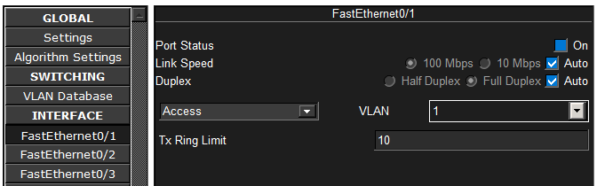

The topology is green and works great again
